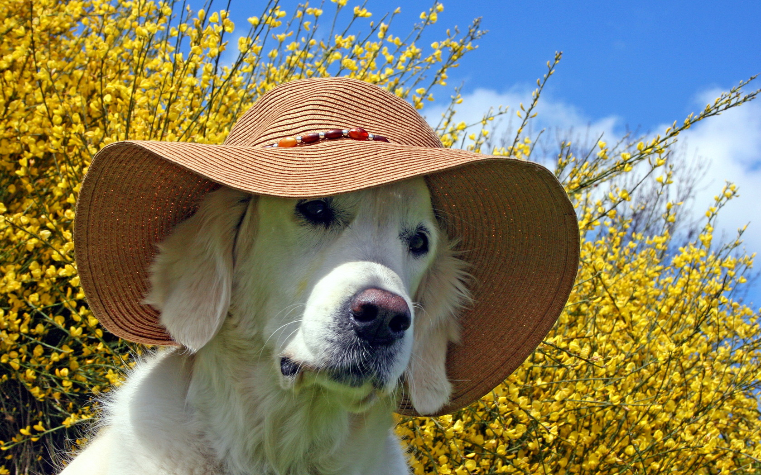
CENAS KRĪT!
LIELĀ VASARAS BEAPHAR
NOLIKTAVAS IZPĀRDOŠANA!
VARBŪT JŪSU MĪLULIM KAUT KAS NODERES?
Art. | Nosaukums | Svars | Derīguma termiņš | Parasta cena par gab.  (ar PVN) | Cena par gab.  ar atlaidi  (ar PVN)
10645 | BEAPHAR KAK-TABL 180 gab. |  | 19.10.2014 | 4,73 | 1,21
12562 | BEAPHAR PUPPY TRAINER | 50 ml | 07.10.2014 | 5,26 | 1,50
12547 | BEAPHAR OFTAL | 50 ml | 12.09.2014 | 4,53 | 1,21
12824 | BEAPHAR SHAMPOO for FERRETS | 200 ml | 12.10.2014 | 3,79 | 1,21
13250 | BEAPHAR Fresh Breath Tablets, 40 tab. |  | 05.12.2014 | 4,82 | 1,21
12826 | BEAPHAR Grooming Spray For Rodents, | 150 ml | 23.11.2014 | 5,26 | 1,21
12623 | BEAPHAR PUPPY PAD, 7 pcs. |  | - | 3,17 | 1,82
11556 | BEAPHAR REPPERS OUTDOOR SPRAY | 250 ml | 01.03.2015 | 8,54 | 4,24
10573 | BEAPHAR Rouletties Mix, 270 pcs. |  | 06.12.2014 | 3,58 | 2,06
10575 | BEAPHAR Rouletties Shrimp, 80 pcs. |  | 02.02.2015 | 1,33 | 0,66
12594 | BEAPHAR KITTY’S CHEESE, 180 TAB. |  | 21.09.2014 | 2,96 | 0,61
13913 | BEAPHAR NO STRESS SPOT ON CAT | 3xpipetes. | 09.11.2014 | 4,82 | 3,00
11039 | BEAPHAR TOTAL SPRAY | 400 ml. | 30.10.2014 | 10,04 | 6,00
12503 | BEAPHAR VITAMIN CAL | 500 g | 17.10.2014 | 5,42 | 3,27
11778 | BEAPHAR FEET BALSAM | 40 ml. | 22.09.2014 | 4,26 | 2,50
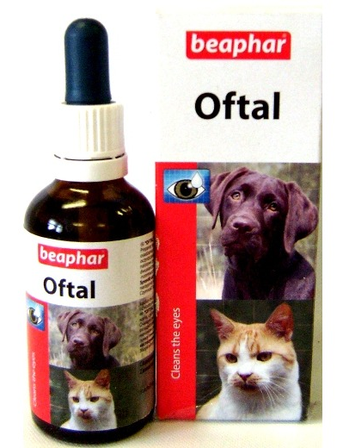
(KĀMĒR PRECE IR NOLIKTAVĀ...)
1.21 Eur

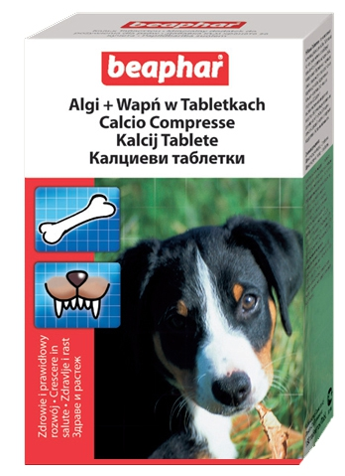

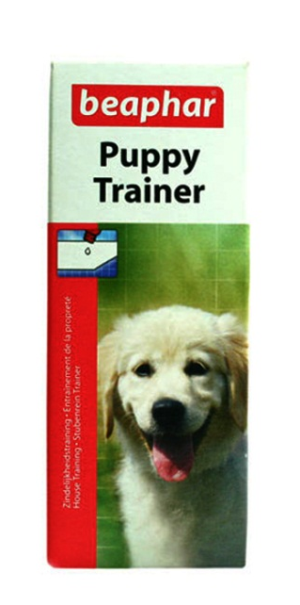

1,21 Eur

1.50 Eur

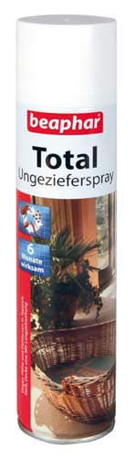
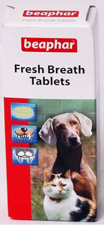
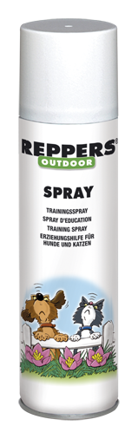
6.00 Eur

1.21 Eur

4.24 Eur

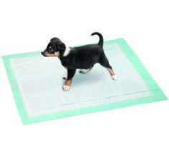
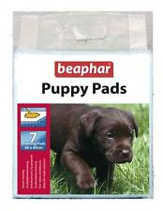
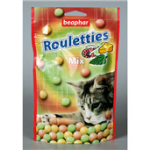
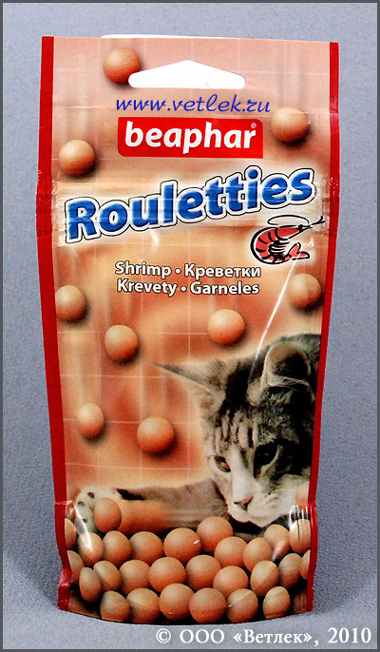
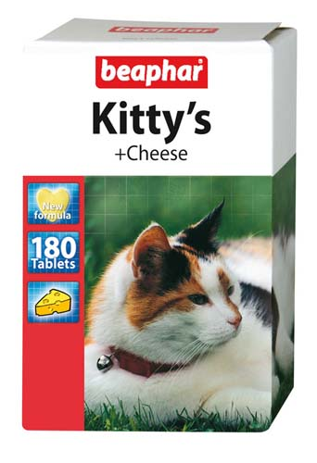
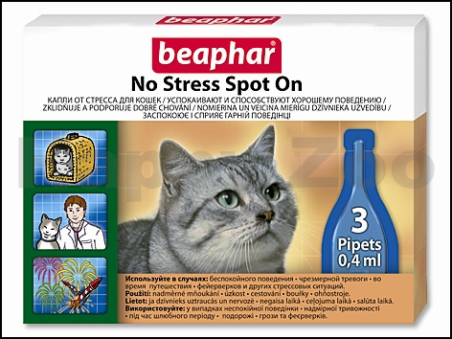
1.82 Eur Eur

2,06
Eur

0,66 Eur

0,61 Eur

3,00 Eur

